**Project Proposal**

**Power Consumption Measuring and Controlling Tool Ver.01**



Power Man Project group

Department of Information and Communication technology

Faculty of Applied Sciences

Rajarata University of Sri Lanka

Content

Topics Pages

1. Introduction 1
2. Background and motivation 1
3. Problem in brief 2
4. Aims and Objectives 2
5. Proposed solution 2
6. Resource requirements 3
7. References 3
8. Appendix 4

i

**Introduction**

These days Electricity has become a major issue in Sri Lanka. Electricity consumption has been increased in our country, with population growth & development. So the Electricity board of Sri Lanka, Spending much more effort to control and reduce the electricity consumption of each and every house, industries and other electricity consuming places. But there is a major problem in it,

Unless people don’t have the facility to monitor the power consumption they can’t control it.

The corporate vision of our client, Domore Technologies (Pvt) Ltd, is to implement a software solution to manage energy consumption of their customers while maintaining an open-minded, dynamic, and customer-centric approach to delivering cutting-edge solutions.

We plan to provide consumers with an engaging, easy-to-use interface to control their appliance power settings on the web or via mobile apps. The huge annual power costs for a SME to top enterprise or a single-family home in the Sri Lanka can be manage and control from wherever they are, hence power consumers can be more energy efficient and realize significant savings.

At this situation our client is in the stage of software product development and hardware product is already completed.

**Background and Motivation**

The power crisis has become a hot topic these days. At present the annual electricity requirement in Sri Lanka is about 11,000 GWh and the installed power plant capacity is about 2700 MW. This consists of 1200 MW of hydropower and 1200 MW of thermal power. The thermal power plant generates electricity by firing coal, Heavy fuel oil (HFO) and diesel. Hydropower is a cheapest option for power generation. But during the dry season, it’s very hard to generate the targeted power from hydro plants.

And currently 85% of power is generated by thermal power plants and the remaining 15% is from hydro plants. As mentioned above, thermal power generation is done using fossil fuel. But these days fossil fuel is require a higher expenditure and in near future there may be a scarcity of fossil fuel. So electricity generation has become a big issue to Sri Lankan economy. As a developing country Sri Lankan economy can’t spend much more amount for growing need of fossil fuel, Hence government tries to regulate the unnecessary power usage of Sri Lankans.

But before regulating this amount, there should be a proper way to monitor the power consumption. So our client wants to give a software solution for this problem as the hardware solution which monitors the electricity consumption of a building.

Our client required and motivated us to implement a web application to sale this device in Sri Lanka and monitor and control this device using remote access.

1

**Problem in brief**

We proposed to give a solution for the problem of how to monitor the electricity consumption, for the purpose of regulating it and a solution to control these electric devices using remote access.

**Aims and Objectives**

The aim of this project is to develop a system for monitoring and controlling the electricity consumption of electric equipments in a house or an industry with the use of Agile methodology.

The objective of this project is to study about the electricity generating problem in Sri Lanka.

* Study about the technologies we are using
* Design and develop a system to solve the problem
* Create an exclusive power monitoring center through this system

**Proposed Solution**

As our system is based on a web application, we intended to design that with following features.

The application will allow the customer to register for an account which requires a username and password. If a user wants to purchase the power controller kit, he can make his deal via this web application. After purchasing and setting this in their home or industry, through this application user can control the device.

Our application can monitor the electricity consumption of ten equipments in his home. He can switch on or switch off these equipments from anywhere in the world through our web application. As well as he will receive an SMS to his mobile indicating the amount and the status of the equipments. For this task we planned to get support from a SMS gateway.

The user can give an energy consumption limit for each equipment and when equipment exceeds that limit, it will also be indicated in our application. So, if the user wants to switch off, he can do it through our application from anywhere.

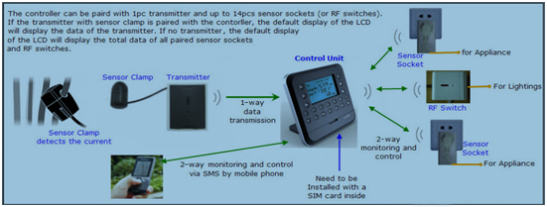

2

**Resource Requirements**

**Hardware Requirements**

1. 2 computers, with 3GB ram and 2.67 GHz processing power, one with Windows operating system and the other with Ubuntu 12.04.
2. Control Unit of the Wireless 2-way home energy monitoring and control system.
3. RJ45-USB data cable, Sensor sockets, Power adapter, RFS switch, 1 way transmitter with sensor clamp.
4. A sim card.

**Software Requirements**

1. My SQL 5.0, Net beans 5.0, Apache 2 and PHP My Admin
2. JQuery, CSS, Java script, XML, XHTML, Photoshop, Dream viewer, Vector magic and Illustrator
3. Internet connection

**References**

[1]“Energy forum Sri Lanka”, Available: http://efsl.lk/ [Online][Accessed: Jan. 07, 2013]

[2]“Sri Lanka targets slashing industrial power use by 10%”, Available: http://www.ft.lk/2012/06/16/sri-lanka-targets-slashing-industrial-power-use-by-10/ [Online] [Accessed: Jan. 07, 2013]

[3]“Monitor Energy Consumption”, Available: http://en.wikipedia.org/wiki/Energy_conservation#Sri_Lanka [Online] [Accessed: Jan. 07, 2013]

[4]“Reliable Electricity Energy Monitor Manufacturer and Developer”, Available: http://www.sailwider-smartpower.com/[Online] [ Accessed: Jan. 07, 2013].

3

**Appendix – Plan of actions**

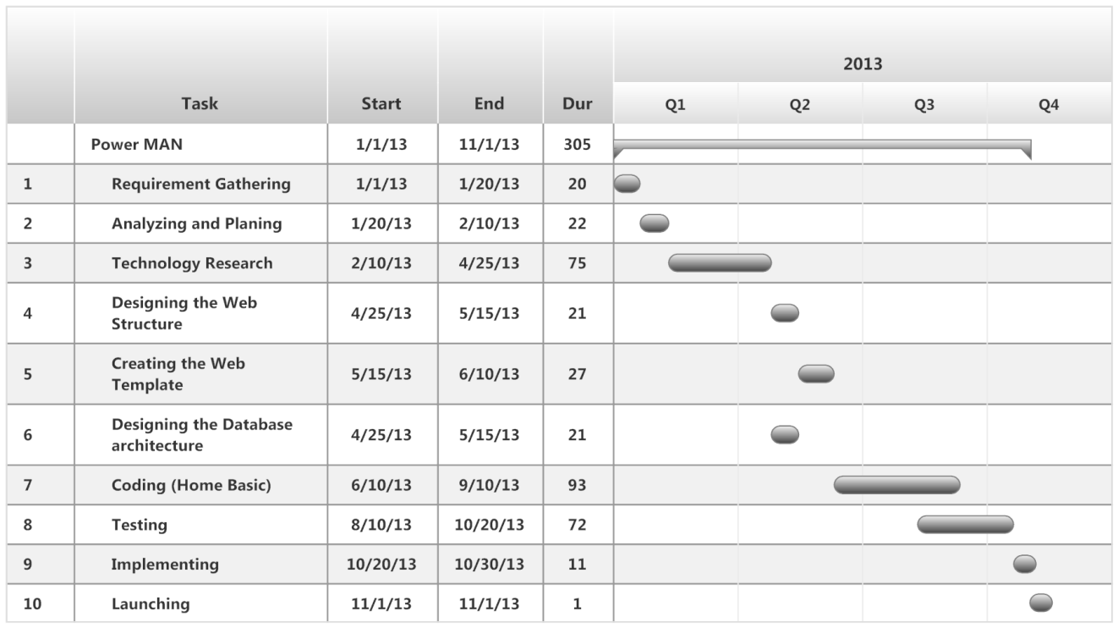

4